20 May

Python Basic - 1

Q.1. What are keywords in python? Using the keyword library, print all the python keywords.

Keyword are the special reserved words that have a specific meaning and can not be used for any other purpose apart from their pre defined usage.

Q.2. What are the rules to create variables in python?

* A variable can consist of upper- and lowercase letters, the digits 0-9 and the underscore character.
* The first character of a variable cannot be a digit.
* Keywords like if or the Boolean True are reserved and cannot be used as variable names.
* Variables are case-sensitive; therefore x is different from X.

Q.3. What are the standards and conventions followed for the nomenclature of variables in

python to improve code readability and maintainability?

* A variable can consist of upper- and lowercase letters, the digits 0-9 and the underscore character.
* The first character of a variable cannot be a digit.
* Keywords like if or the Boolean True are reserved and cannot be used as variable names.
* Variables are case-sensitive; therefore x is different from X.
* Camel casing is a good idea
* If the variable name is more than one word, try using _ (underscore as well).

Q.4. What will happen if a keyword is used as a variable name?

This situation will create a confusion for the developer and the interpreter first of all. And if you still use it , it will give you a syntax error.

Q.5. For what purpose def keyword is used?

Def keyword is used to define a function. It is placed before a function name provided by the programmer.

Q.6. What is the operation of this special character ‘\’?

Separates location in a file or a network path.

Q.7. Give an example of the following conditions:

(i) Homogeneous list

It contains only single type of data. Eg: a=[1,2,3,4] . Here, a is a list containing all integers.

(ii) Heterogeneous set

They contain data of different data types. Eg: b=[1,’sawi’, 3.14]. Here, b is a list containing values of different data types like integer, string, float,etc.

(iii) Homogeneous tuple

They are the tuples containing data of the same type. Eg: c=(1,2,3) . Here, c is a tuple containing values of same data type.

Q.8. Explain the mutable and immutable data types with proper explanation & examples.

Mutable data types: their value can be change even if they are already declared.

Immutable data types: you can not change their value once they are declared.

Mutable data types in python:

* Lists
* Dictionaries
* Sets
* User-Defined Classes (It depends on the user to define the characteristics of the classes)

Python immutable data types:

* Numbers (Integer, Float, Complex, Decimal, Rational & Booleans)
* Tuples
* Strings

Q.9. Write a code to create the given structure using only for loop.

*

***

*****

*******

*********

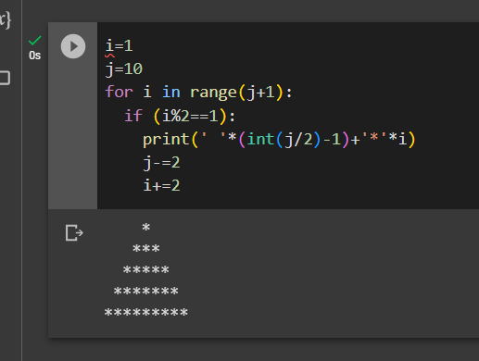

Q.10. Write a code to create the given structure using while loop.

|||||||||

|||||||

|||||

|||

|

